UNIVERSITY OF DAR ES SALAAM


COLLEGE OF INFORMATION AND COMMUNICATION TECHNOLOGY
DEPARTMENT OF ELECTRONICS AND TELECOMMUNICATIONS ENGINEERING
FINAL YEAR REPORT-MID SEMESTER TWO
PROJECT TITLE: DESIGN AND IMPLEMENTATION OF AN AUTOMATIC ID CARD ISSUANCE SYSTEM

Student’s Name: Samuel Dan Musyani
Registration Number: 2022-04-09050
Supervisor’s Name: Dr. Hashimu Iddi

ABSTRACT
The issuance of student identification cards in many higher learning institutions is often characterized by long processing times as a result of manual verification within a narrow working window. This project proposes the design and implementation of an automated self-service student ID card issuance system aimed at improving efficiency, security and all-time reliability of issuance process. The system is an embedded system with peripheral devices for user authentication, data collection, card issuance, back-end communication together with database access. The proposed project will be evaluated based on authentication success rate, dispense rate, issuance accuracy, and system’s reliability.
The outcome of this project is expected to be a functional prototype demonstrating an automated secure student ID card issuance system suitable for University environments.

TABLE OF CONTENTS
ABSTRACT ii
TABLE OF CONTENTS iii
LIST OF TABLES v
LIST OF FIGURES vi
LIST OF ABBREVIATIONS vii
CHAPTER ONE: INTRODUCTION 1
1.1 EXECUTIVE SUMMARY 1
1.2 BACKGROUND 1
1.3 PROBLEM STATEMENT 2
1.4 MAIN OBJECTIVE 2
1.5 SPECIFIC OBJECTIVE 2
1.6 SIGNIFICANCE OF STUDY 2
1.6 SCOPE AND LIMITATIONS 3
CHAPTER TWO: LITERATURE REVIEW 4
2.1 RELATED PROJECTS 4
2.2 RESEARCH GAP 4
CHAPTER THREE: SYSTEM DESIGN AND METHODOLOGY 5
3.1 SYSTEM ARCHITECTURE 5
3.2 FUNCTIONAL WORKFLOW 6
3.3 COMMUNICATION PROTOCOL 8
3.4 SYSTEM CIRCUIT DESIGN AND ITS ARCHITECTURE 8
3.4.1 COMPONENTS USED 8
3.4.2 HARDWARE CIRCUIT ARCHITECTURE 9
3.4.3 POWER REGULATION 10
3.4.4 ARDUINO MEGA CORE CIRCUIT DESIGN 10
3.4.5 MOTOR DRIVER AND ACTUATION CIRCUIT DESIGN 11
3.5 COMPUTER VISION DESIGN INTEGRATION 11
3.5.1 DESIGN DETAILS 11
3.5.2 PROCESSING PIPELINE 11
3.6 BACK-END AUTHENTICATION DESIGN 12
3.6 MECHANICAL DESIGN 13
3.7 PROJECT SCHEDULE 13
3.8 PROJECT BUDGET 15
CHAPTER FOUR: SOFTWARE IMPLEMENTATION 16
4.1 RASPBERRY PI APPLICATION 16
4.1.1 COMPUTER VISION MODULE 16
4.1.2 USER INTERFACE 18
4.1.3 OTP GENERATION AND VERIFICATION 24
4.1.4 UNIVERSITY API INTEGRATION AND SLOT ASSIGNMENT 24
4.2 DATABASE ARCHITECTURE – KIOSK LOCAL 25
4.3 API CLIENT MODULE AND SMS DELIVERY 26
4.4 SESSION MANAGEMENT 26
4.5 CONFIGURATION MANAGEMENT 27
CHAPTER FIVE: HARDWARE IMPLEMENTATION AND PROGRESS 28
5.1 MICROCONTROLLER SELECTION AND CONFIGURATION 28
5.2 SPI SLAVE CONFIGURATION 28
5.3 SPI COMMUNICATION PROTOCOL 28
5.4 SERVO MOTOR CONTROL 29
5.5 FIRMWARE ARCHITECTURE 29
5.6 PERFORMANCE BENCHMARKS 30
CHAPTER SIX: RECOMMENDATIONS AND CONCLUSION 31
6.1 RECOMMENDATIONS 31
6.2 CONCLUSION 31
REFERENCES 32

LIST OF TABLES
Table 1: Hardware components 9
Table 2: Software components 9
Table 3: Project Budget 15
Table 4: Schema Overview 25

LIST OF FIGURES
Figure 1: System’s block diagram 5
Figure 2: Staff-side functional workflow 7
Figure 3: Student-side workflow 7
Figure 4: XL4015 buck converter 10
Figure 6: Processing pipeline workflow 11
Figure 7: Circular storage chamber 13
Figure 8: Semester 1 activity plan (Gantt Chart) 13
Figure 9: Semester 2 activity plan (Gantt Chart) 14
Figure 10: Sample card detected (green line shows detection) 16
Figure 11: Processed grayscale sample image 17
Figure 12: Adaptive thresholding on a sample card. 17
Figure 13: ROI settings for OCR 18
Figure 14: Previews of ROI outputs 18
Figure 15: Text extraction and processing performances 18
Figure 16: Idle UI screen for card kiosk 19
Figure 17: Initial registration number screen 19
Figure 18: Registration entry screen for a repeated card 20
Figure 19: Registration entry screen for unavailable card 20
Figure 20: SMS message sent to sample student 21
Figure 21: OTP initial screen 21
Figure 22: Incorrect OTP screen 21
Figure 23:Temporary PIN screen – intial 22
Figure 24: Incorrect PIN entered 22
Figure 25: Hardware card dispensing - background 23
Figure 26: Final confirmation screen 23
Figure : OTP generation 24
Figure : Bcrypt hashing with salt rounds 24
Figure : SPI poll initialization 29
Figure : Frame extraction from buffer 30
Figure : Dispatch to state machine 30
Figure : Choice statements 30

LIST OF ABBREVIATIONS
ABBREVIATIONS | LONG FORM
2FA | 2-Factor Authentication
API | Application Program Interface
CAD | Computer Aided Design
CLK | Clock
CS | Chip Select
DB | Database
GB | Gigabyte
ID | Identification
IoT | Internet of Things
MISO | Master In Slave Out
MOSI | Master Out Slave In
OCR | Optical Character Recognition
OS | Operating System
OTP | One Time Password
PVC | Poly-Vinyl Chloride
PWM | Pulse-Width Modulation
RAM | Random Access Memory
SMS | Short Message Service
SPI | Serial Peripheral Interface
Wi-Fi | Wireless Fidelity

CHAPTER ONE: INTRODUCTION

1.1 EXECUTIVE SUMMARY
On this document, a comprehensice technical report on the Automated ID Card Issuance System is provided. The system automates the collection and issuance of pre-printed student ID cards withing the University environment, addressing operational inefficiencies in manual card distribution process.
The implementation comprises of two primary computation entities: a raspberry Pi 5 serving as the application controllers and an Arduino Mega which was earlier to be STM32 Nucleo-F401RE handling real-time hardware control. Communication between the two micro-controllers are made through Serial Peripheral Interface, utilizing a two-byte ASCII frame protocol.
Key achievements in the current phase include:
- Fully functional OCR pipeling for batch card registration using OpenCV and Tesseract
- Bcrypt-secured credential storage with configurable lockout policies
- SQLite database with immutable audit loggig for regulatory compliance
- SPI master implementation of Raspberry Pi and slave firmware on Arduino Mega
- Integration with BRIQ Solutions SMS API for out of band OTP delivery

1.2 BACKGROUND
Universities commonly issue student ID cards that serve as proof of registration and campus identification for various services to students. At the University of Dar es Salaam, the card collection process, which occurs immediately after students have completed registration, involves queuing at the responsible office for collection. However, for a high volume of students, this results in long waiting times, narrow service windows (only operating during working hours), and staff exhaustion.
Therefore, the project aims to develop a prototype of an Automated ID Card Issuance System that sorts and gives out pre-printed ID cards to students on demand at all times. The system integrates a microcontroller that controls actuators in real-time, a single-board computer that performs computer vision (for ID identification), student’s identity authentication, logging of various activities, and back-end integration. The intended solution aims to reduce distribution time while ensuring secure ID card distribution as it is.

1.3 PROBLEM STATEMENT
The current student ID card issuance process at University of Dar es Salaam involves a waiting period of approximately one week after registration due to delayed card availability in the individual’s college. After release, the card collection also requires students to queue and sort a bunch of ID cards. So, for a high volume of students, the staff responsible suffers significant work strain. On top of that, fixed hours also hinder the sorting capacity of students' issuance per time. As a result, card issuance for registered students takes up to several days, which may bring inconvenience to students.

1.4 MAIN OBJECTIVE
Design and implementation of an Automated ID Card Issuance System for pre-printed student ID cards with secure authentication and audit logging while serving students at all times.

1.5 SPECIFIC OBJECTIVE
- To implement a reliable control system for actuators using a microcontroller capable of selecting and dispensing a single card from a pile of cards in a stored compartment.
- To implement a computer board application that gives out authentication OTPs, verifies the student’s set pin, receives the user registration data, verifies it against a database, and communicates the command to the microcontroller.
- To implement robust logging of each transaction details in database for auditing and debugging.
- To implement security policy that uses SMS-delivered OTPs as authentication mechanism, and also enforce measures to deal with invalid attempts and communication to system admin.
- To evaluate system performance using metrics such as average card retrieval time, authentication success, error handling and dispense rate.
- To produce a formal report involving design of the prototype at various milestones.

1.6 SIGNIFICANCE OF STUDY
- Operational efficiency: the proposed system reduces long queues and waiting times by allowing students to retrieve ID cards on demand without any staff intervention.
- Reduced administrative burden: the system performs automation which replaces the repetitive tasks done by a university staff allowing them to focus on higher level tasks.
- Scalability, accessibility and replicability: Although the proposed system is implemented as a prototype for UDSM, the system can be adopted by other institutions such as banks for card applications. Also, access to students retrieving their ID cards beyond standard normal working hours.
- Academic contribution: the project demonstrates practical application of embedded systems, back-end software and other mechanical design theory and automation studied as theory in various academic year(s).

1.6 SCOPE AND LIMITATIONS
This project focuses on the design and implementation of an Automated ID Card Issuance System which integrates the software part (back-end, user interaction and computer vision verification) and hardware part with microcontroller and actuators for card sorting and dispensing the said card. Therefore, the prototype does not implement on-device printing of the PVC cards, mobile application or payment gateway.
The system intends to use a mock database for testing unless institutional access is granted.

CHAPTER TWO: LITERATURE REVIEW
In this chapter, various existing systems, projects and technologies related to the proposed project are reviewed. The purpose of the review is to understand different approaches, scope, limitations and gaps and hence, establish basis of the proposed project. Therefore, the following points gathered below feature ideas with similar concepts as the proposed project.

2.1 RELATED PROJECTS
- Automatic and Smart Vending systems: these are some self-service systems that provide mostly goods (foods) to users without much human intervention, mostly observed in supermarkets for snacks and beverages. These systems have two categories: non-IoT machines, which operate by giving physical cash to the machine, and IoT machines, which work with cashless payments and track the availability of stock, locations to satisfy customer preferences by using microcontrollers (Ratnasri & Sharmilan, 2021). Also, some vending systems apply image processing with deep learning to detect and categorize various target objects of interest in the image. These kinds of vending machines also implement a weight data acquisition part to increase the accuracy of target object detection (Xia, K., Fan, H., Huang, J., Wang, H., Ren, J., Jian, Q., & Wei, D).
- System architectures and control strategies: in most of the dispensing applications, generally a microcontroller is used with a communication module, mostly Wi-Fi, with a logic to directly manage actuator control, sensor inputs, safety interlocks, and communicate with the server or a computer for other complex tasks (Prasad, Kumar, Shriram, Prof. Dr. Mane, 2024).
- Authentication and security: this is one of the most critical part of the system that deals with sensitive items. In automated environments, combining multiple verification layers (e.g OTP, biometrics, card scanning) improves security. In ATM systems, work on authentication explores multi-factor approaches, integrating OTPs with biometric factors to reduce unauthorized access risk (Kibaya, Lubobya, 2024).

2.2 RESEARCH GAP
From the related projects, the proposed system aims to cover the gap that despite an extensive research on vending and kiosk systems, limited number of projects addresses secure low-cost automated distribution of pre-printed identification cards particularly in University environments.

CHAPTER THREE: SYSTEM DESIGN AND METHODOLOGY
This chapter reviews various procedures to design, build and evaluate the performance of the prototype. It covers system architecture, hardware and software selection together and security.

3.1 SYSTEM ARCHITECTURE
High-level controller will be used to control the user interface, network connectivity, 2FA for OTP and student’s pin, database access, computer vision verification, transaction logging, and command issuing to the real-time controller. Then, a real-time controller will be used to directly control the motor, safety monitoring (limit switches), status reporting, and mechanical card sorting and ejection.
The pre-printed cards will be organized in indexed storage sections, which will be mapped to existing barcodes on the ID cards. Local (mock) database will be used to replicate the University DB scheme, and testing will emulate that unless permission is granted to access the database (API).
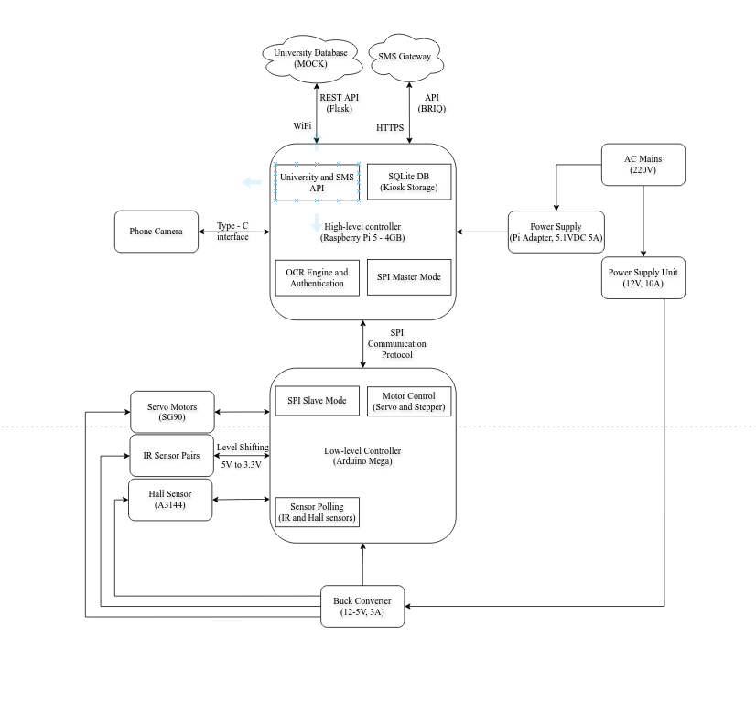
Figure 1: System’s block diagram

3.2 FUNCTIONAL WORKFLOW
- Preload phase: responsible staff inserts a bunch of pre-printed cards into the dispenser, then the machine runs a routine scan and maps each card into a slot index in the dispenser DB. The high-level controller records the mapping with the individual card.
- Notification phase: when the cards are available, right after the routine scan, the high-level controller initiates triggering of SMS to particular students. The SMS includes an OTP valid for one retrieval attempt. If it is the particular student’s first time use, and extra different and temporary pin is sent via SMS for 2FA.
- Retrieval phase: First, students scan their expired card, and their information is shown on the screen (registration number, name, and degree programme), then an OTP prompt follows, as received from the SMS. Thereafter, the high-level controller validates the OTP and prompts for the student’s pin for extra layer of authentication. If it is the student’s first time use, after the prompt, the system gives a form to register a new custom pin which will be permanent for each individual.
After that, high-level sends the dispense command to the low-level controller to start the card dispensing process. The low-level microcontroller executes the motion to retrieve the card and verifies the card and its presence, and performs ejection while updating and returning the status to the high-level controller. Lastly, the high-level controller logs the transaction to the database as the audit logs.
- Security measures: after 3 invalid attempts for the same registration number within the same session, the system flags that particular number as locked for amount of time, notifies the system admin and returns to the home screen. In addition to that, in case of any physical tampering, the system alerts the admin and shuts down until manual admin reset is performed.
Below are the functional workflows featuring both student-side and staff-side access of the system:
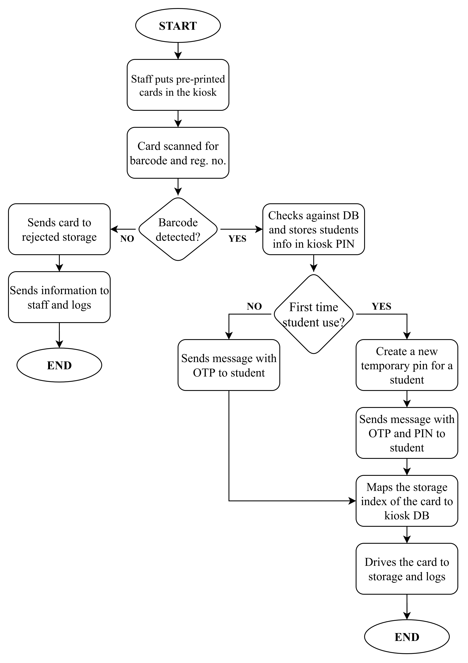
Figure 2: Staff-side functional workflow
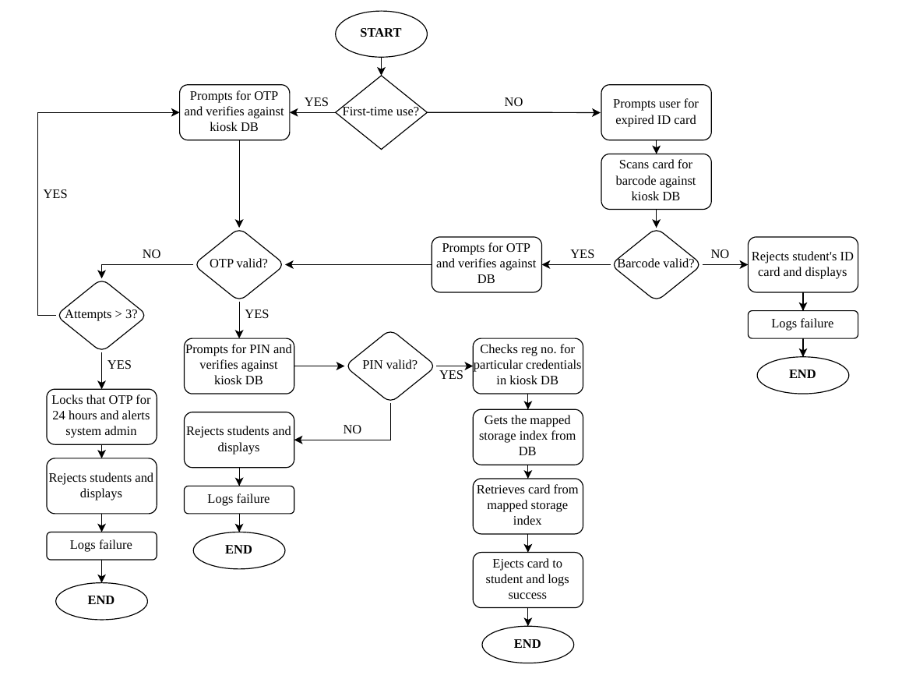
Figure 3: Student-side workflow

3.3 COMMUNICATION PROTOCOL
The communication protocol targeted between high-level controller and low-level controller is SPI, which has four wires (CLK, MOSI, MISO, CS) plus common ground, where Raspberry Pi is the master, with Arduino Mega as its slave. These communication signals from Raspberry Pi operate at 3.3V, while the signals from Arduino Mega operates at 5V. Since the Raspberry Pi is the master, signals at 3.3V were well – managed by the Mega counterpart. Arduino Mega does not communicate to Raspberry Pi, therefore only 3 wires used without level shifting of the voltage.
This communication protocol was selected due to high speed synchronous communication, full-duplex capability, simple hardware implementation and very reliable short distance communication.
Within this protocol, the commands (light messages) will be the ones to initiate various activities by the high-level controller through low-level controller done by the actuators.

3.4 SYSTEM CIRCUIT DESIGN AND ITS ARCHITECTURE

3.4.1 COMPONENTS USED
The hardware and software tools selected for this project were chosen based on their performance requirements, need for scalability and compatibility with each other.
COMPONENTS | PICTURE | FUNCTIONALITY
Raspberry Pi 5 (4GB RAM) |  | Hosts back-end application, OTP generation, database access, logging, computer vision and communication with low-level controller.
Arduino Mega |  | Directly drives actuators, reads sensors and timing and safety logic.
Buck converter |  | Converts 12VDC to a clean 5VDC for component usage.
Camera module V2 | 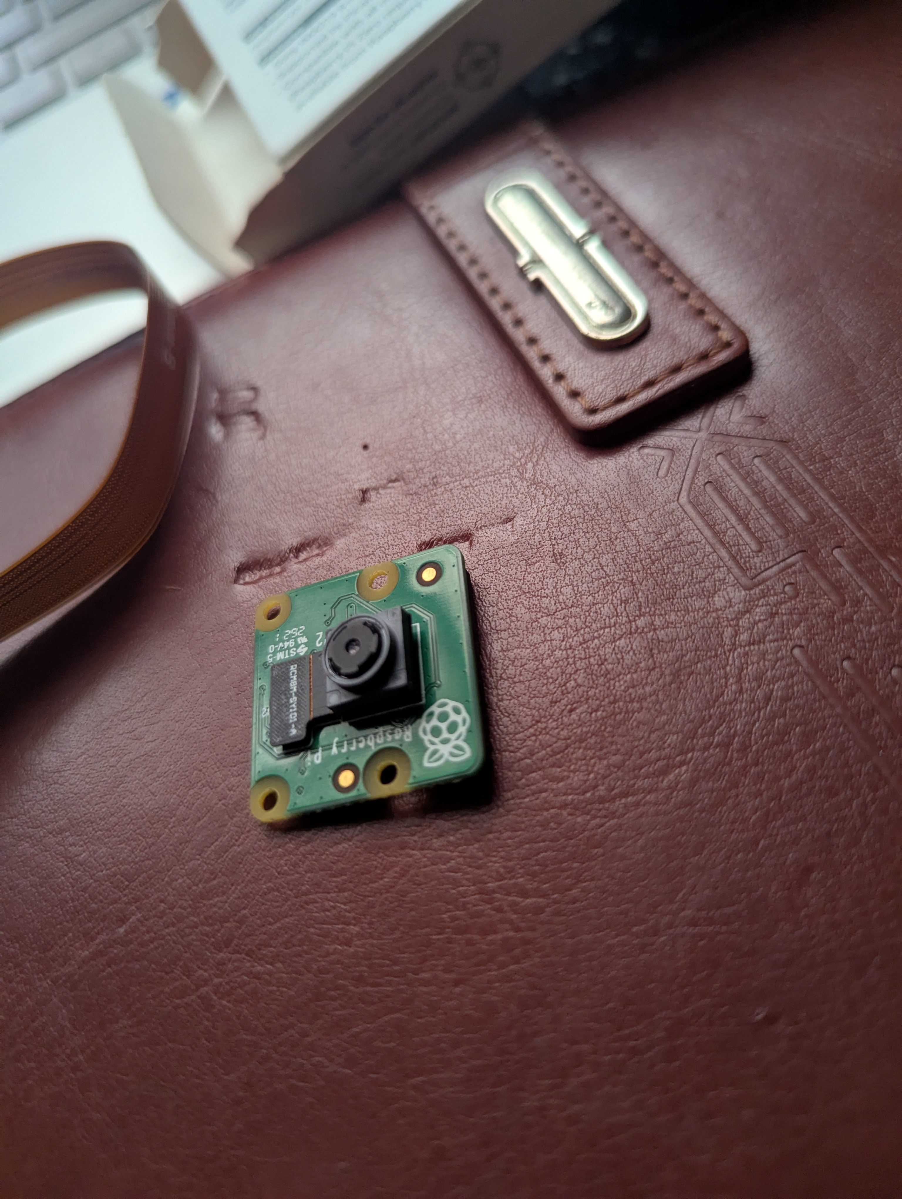 | Visual images for card to support computer vision tasks.
Servo SG90 motor |  | Move sorting mechanisms, control card selection and ejection.
Power Supply | 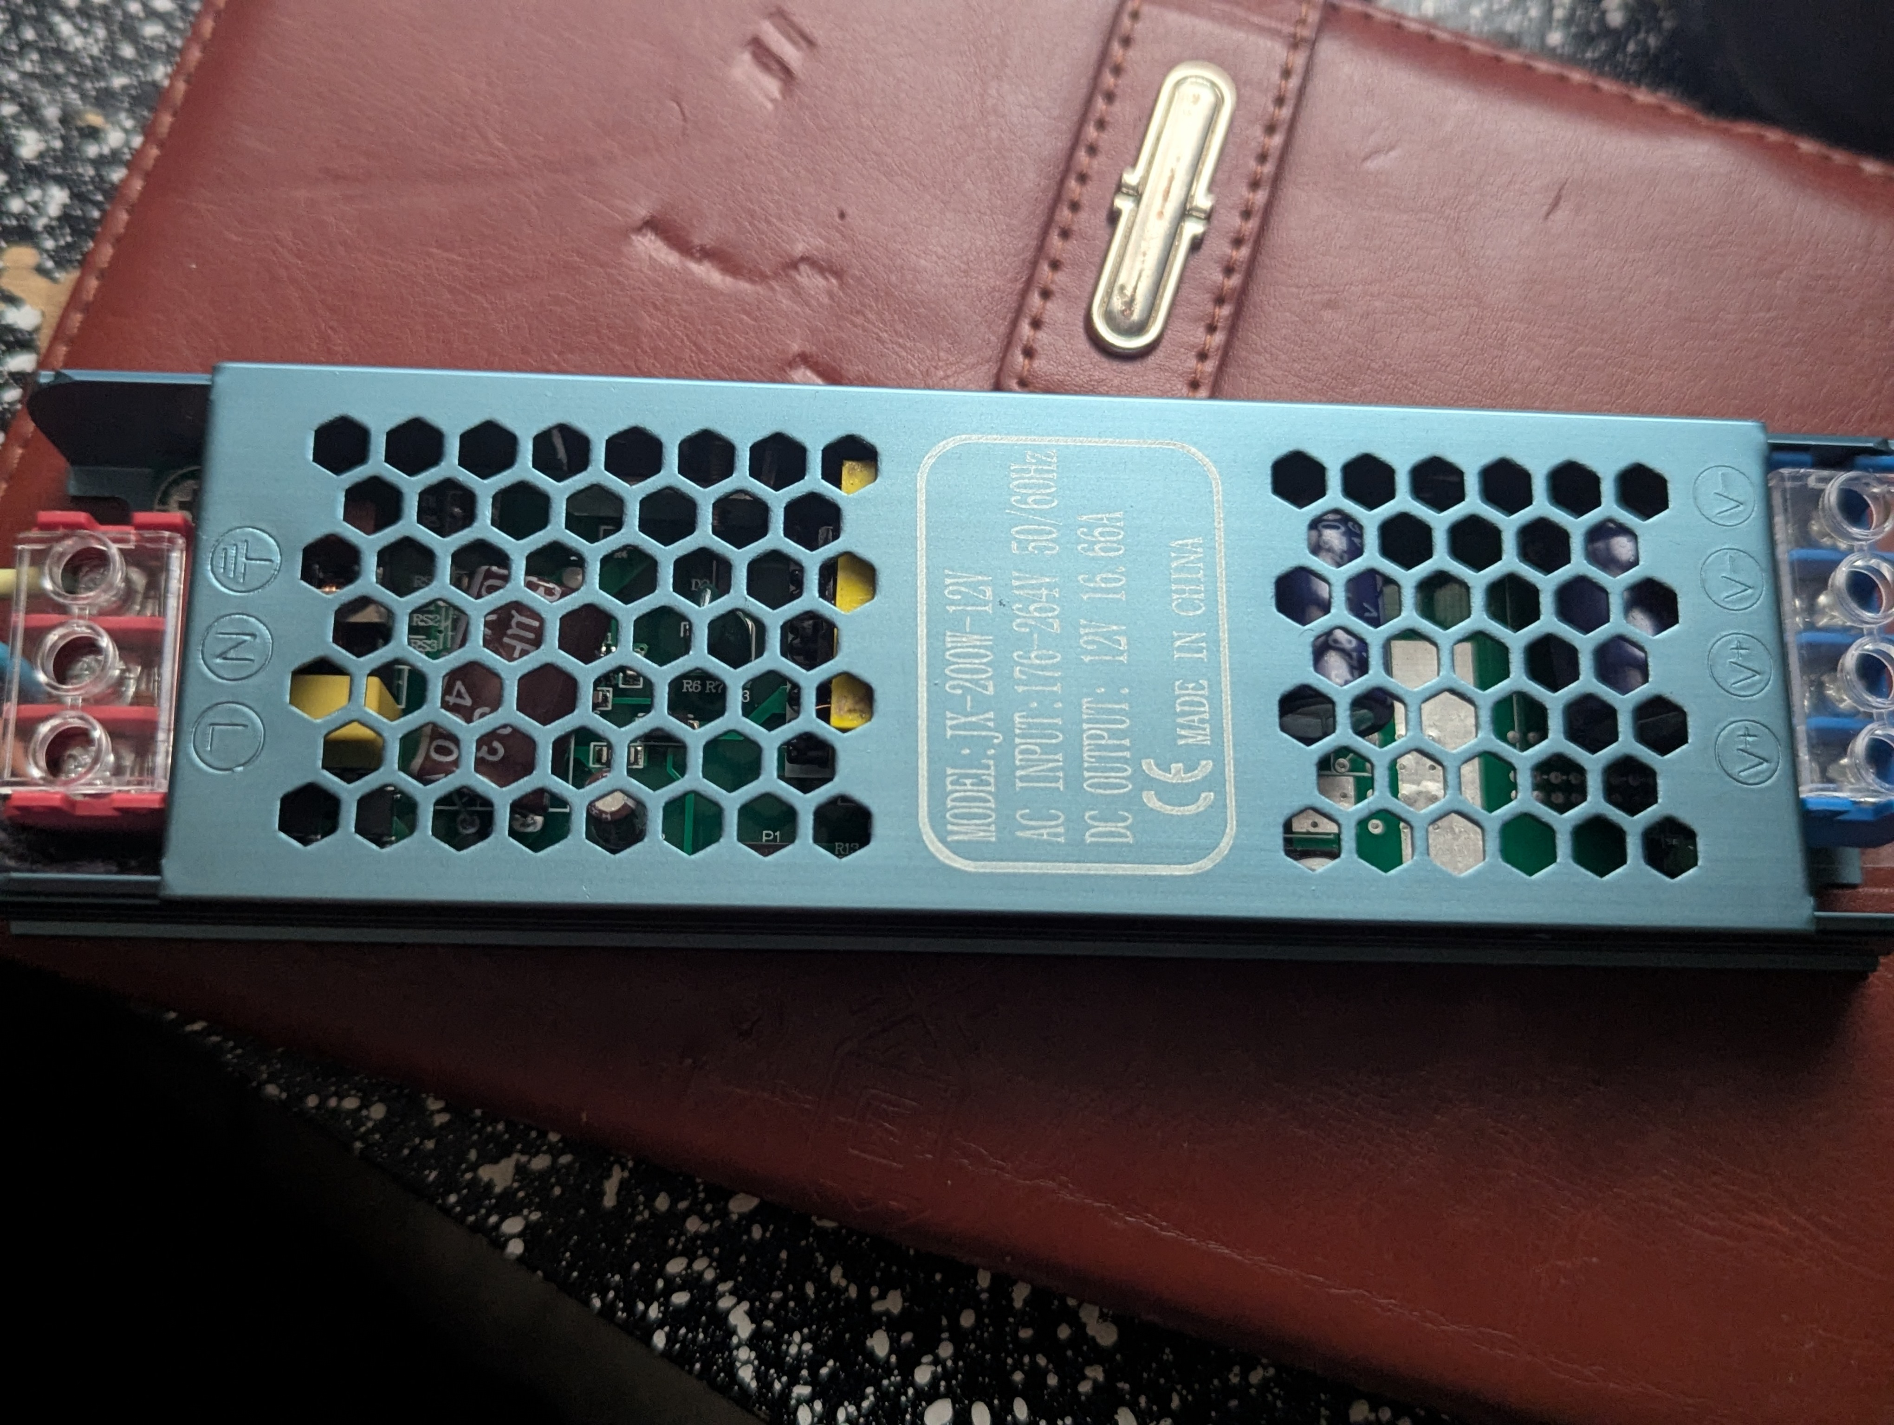 | Conversion of 220VAC to suitable 12VDC for logic and control signalling.
Table 1: Hardware components
The following are the software proposed to be used in this project:
SOFTWARE COMPONENT | FUNCTIONALITY
Raspberry Pi OS | supporting system of the high-level controller.
Back-end Application | handles user input, authentication, interfaces with database, sends commands to low-level controller and manages error handling.
Database | stores students data and logs.
Computer Vision libraries | supports card insertion and ejection verification.
Low-level controller Firmware | executes motor control routines, reads sensors, implements communication and monitors safety.
Table 2: Software components

3.4.2 HARDWARE CIRCUIT ARCHITECTURE
The hardware part of the Automated ID Card Issuance System is designed to support controlled mechanical actuation, stable power distribution and reliable communication between controllers. The circuit design was developed using Altium. The architecture design is divided into various design modules which include power regulation sub-system, Arduino Mega circuit control circuit, motor driver and actuation circuit and communication circuit interface.

3.4.3 POWER REGULATION
The system has two controllers that operate at 5V but with different current drawing capabilites. Raspberry Pi has peripherals to feed power and a hungry processor that needs up to 5A to work correctly, along with Arduino Mega that also uses the same voltage with only up to 2A with full working load.
Due to that fact, the power concern was divided across each component individually. First, a dedicated Raspberry Pi adapter (Type – C) capable of converting 220VAC to 5VDC with 5A current rating to supply for the high – level controller. Secondly, a power supply that converts 220VAC to 12VDC was integrated with a buck converter that converts 12VDC to 5VDC with up to 3A current rating. This is designed to power the Arduino Mega and servo motors which uses 5V also.
The raw designs for buck converter using XL4015 are still presented below;
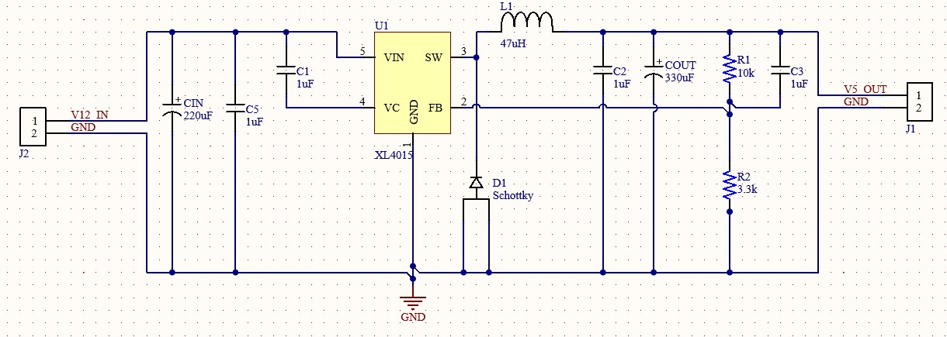
Figure 4: XL4015 buck converter

3.4.4 ARDUINO MEGA CORE CIRCUIT DESIGN
The Arduino Mega controller defines a real-time control of the system’s actuation and deterministic behaviours. Therefore, the core design includes: proper power supply connections with decoupling capacitors to reduce power supply variations and configuration of boot pins.
Arduino Mega programming interface platform to be used will be platfromIO, together with Visual Studio Code IDE as an environment to program a low-level microcontroller used. At this stage, those applications use a way of debugging that needs a hardware (chip or board) which is not yet implemented. On the next stage of this project, programming and implementation of the project will follow along.

3.4.5 MOTOR DRIVER AND ACTUATION CIRCUIT DESIGN
The actuation sub-system is designed to control servo motors responsible for card transport and dispensing. The motor driver circuit is designed to interface with an MCU (Arduino Mega) through various control inputs and enable logic to drive the motors efficiently.
The motor power rail is efficiently extracted from a clean conversion from a XL4015 buck converter that gives out a constant of 5V (ideally) and up to 3A that gives a larger head room since servo motors only need up to 700mA to work efficiently. All reference points from the motors, MCU, converters and sensors are to be connected to one points.

3.5 COMPUTER VISION DESIGN INTEGRATION
The computer vision module’s aim is to detect and extract information from the inserted cards, either by the students or staffs. It performs OCR-based extraction of student’s registration number. The extracted data was chosen to be the registration number because it is unique for each student with no duplicate complications.

3.5.1 DESIGN DETAILS
The initial barcode-verification revealed some sensitivity to orientation variation and reflection hence OCR-based design was selected to reduce dependency on alignment of the card with lights and flexibility since text are relatively larger hence easier to identify than the barcodes.

3.5.2 PROCESSING PIPELINE
The proposed system design factored the PI camera capturing images of the cards, and the high-level controller processing them to extract the registration via OCR-based detection methods. Therefore, the processing pipeline consists of the following stages:
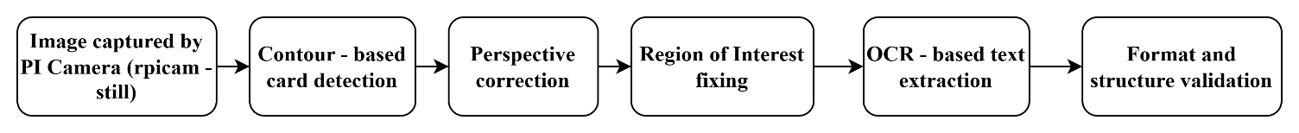
Figure 6: Processing pipeline workflow
From the functional workflow, card detection is designed using edge detection and contour extraction techniques which are filtered according to geometric constraints such as minimum area and aspect ratio according the CR80 standard card size. Once a contour is detected, a perspective transformation is done to obtain a clear frontal view of the card to improve OCR detection stability.
The region of interest is determined by trial-and-error fixing according to the pixel cards. The format is (x, y, w, h) coordinates.
The extracted region is processed used OCR, and configured to prioritize numeric text recognition first. Then, after extraction by OCR, the expected format of registration number “YYYY-NN-XXXXX” is validated. Only the text that fits the description of format is considered as success.

3.6 BACK-END AUTHENTICATION DESIGN
The back-end system is designed to manage identity validation, authentication control and system logging for audits. Therefore, it acts as a bridge between the computer vision results and the low-level controller activities. If the authentication goes wrong, low-level controller cannot perform any mechanical activity. The sub-system performs three important services:
- Student verification service
- OTP Authentication service
- Audit logging service.
After a successful extraction of the registration number from computer vision processes, the back-end verifies the number against the University database and fetches information about the particular student and stores the registration number to the local system’s database. Only valid and active records are passed to authentication.
The main authentication mechanism is based on a One-Time Password (OTP) model. Each OTP produced is designed according to standard security principles:
- Randomized OTP generation
- Secure storage using hashing
- Time-limited validity
- Restricted number of attempts.
The OTP delivered to the student using a SMS gateway. During retrieval, the student inputs the received OTP through the user interface designed. Back-end then compares the hashed input against the stored and logs the action in either case, failure or success. The logging design ensures accountability and traceability.

3.6 MECHANICAL DESIGN
As the system requires a staff to load a pile of cards into a machine, and it sorts out each card according to the information and stores it, here is the design of it. The card sorting and storage system, will be a combination of stepper motor and a circular bin calculated with each slot to an assigned mapped number stored in the system’s database (Halac et al, 2025). If the card is needed, the bin is rotated by the servo motor up to the calculated position and a card is taken/ejected from the bin.

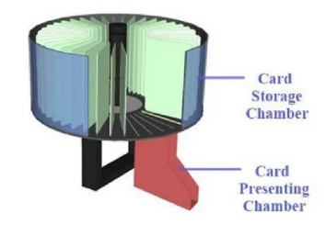
Figure 7: Circular storage chamber

3.7 PROJECT SCHEDULE
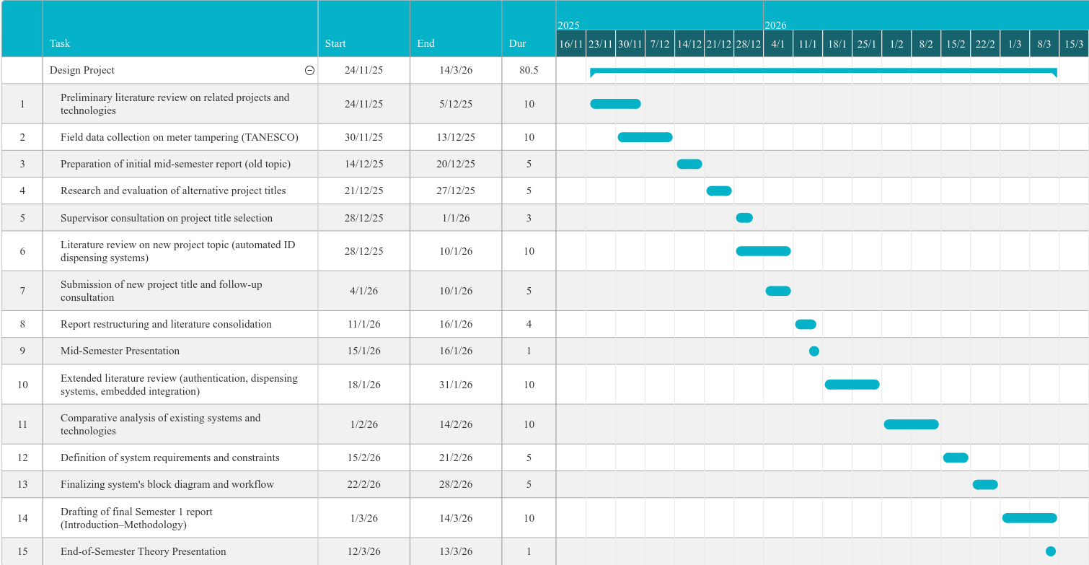
For first semester, the following Gantt chart shows various activities planned for proposed system:
Figure 8: Semester 1 activity plan (Gantt Chart)
For second semester, the following Gantt chart shows various activities planned for proposed system:
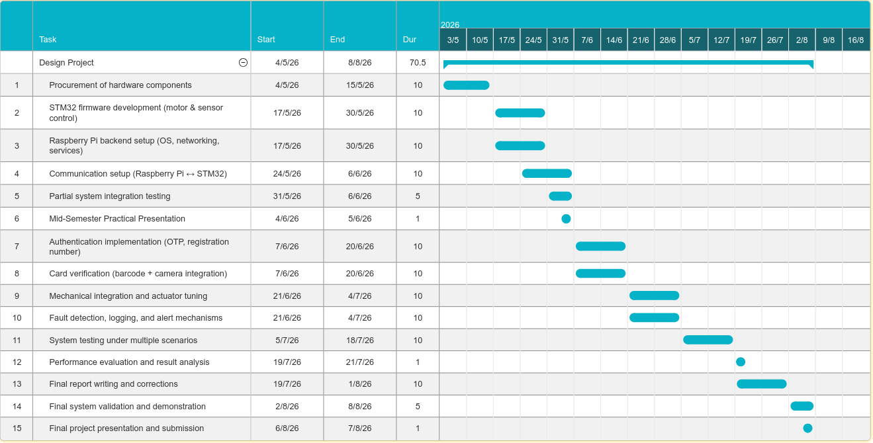
Figure 9: Semester 2 activity plan (Gantt Chart)

3.8 PROJECT BUDGET
From the local electronics shops visited, estimated total cost of the proposed system is computed as follows:
COMPONENT | ESTIMATED COST (TSh)
Raspberry Pi 5 (4GB) | 290,000
Low-level controller (Arduino Mega) | 60,000
Raspberry Pi Camera | 67,000
Actuators (Motors and their drivers) | 65,000
Sensors | 25,000
Enclosure and miscallenous components | 70,000
Power Supply | 13,000
Interfacing modules | 30,000
Perfboards and soldering equipments | 55,000
Minor repairs | 23,500
TOTAL | 563,500
Table 3: Project Budget

CHAPTER FOUR: SOFTWARE IMPLEMENTATION
This chapter depicts a complete implementation done (software) for the Automated ID Card Issuance System. The software parts involve the computer vision module for OCR detection and text extraction, authentication and SMS gateway configuration and user interface integration and transmission. This part of software will communicate with the hardware part which is in development for actual card sorting and ejection.

4.1 RASPBERRY PI APPLICATION
This sub-system implementation was done in a controlled Raspberry Pi OS. The focus on this was development and testing of the computer vision module and back-end authentication system together with the whole pipeline of these.
In the said raspberry Pi OS, other implementation environment and virtual environments included: python programming language, Open-CV library for image processing, Tesseract OCR engine for OCR detection, Fast API framework for back-end services and SQLite/PostgreSQL database for student records. Virtual environments were used to isolate system packages from the system’s.

4.1.1 COMPUTER VISION MODULE
Implementations for computer vision module was done as follows:
- Image capturing was done by a phone camera, transferred and stored in the raspberry Pi memory for processing. This is done as a placeholder for a Pi camera V2 module which is yet to be delivered in the country.
- Card detection and perspective correction, contour-based detection was implemented to identify quadrilateral shapes (card shape) and the smoothing using gaussian thresholding (adaptive) was applied to improve OCR consistency by reducing distortions. Below are the results of card detection, green lines show verification:

Figure 10: Sample card detected (green line shows detection)
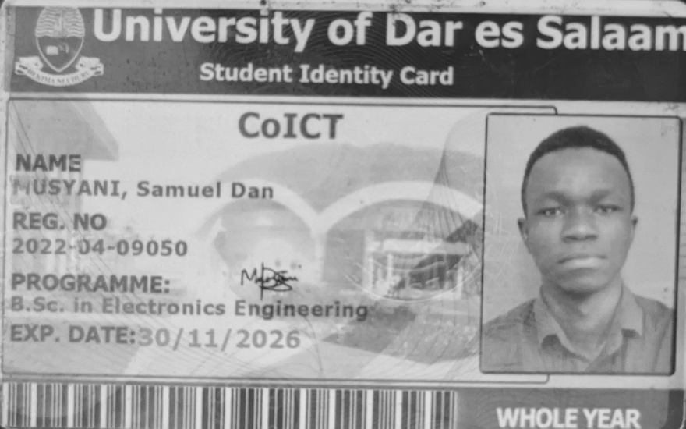
Figure 11: Processed grayscale sample image

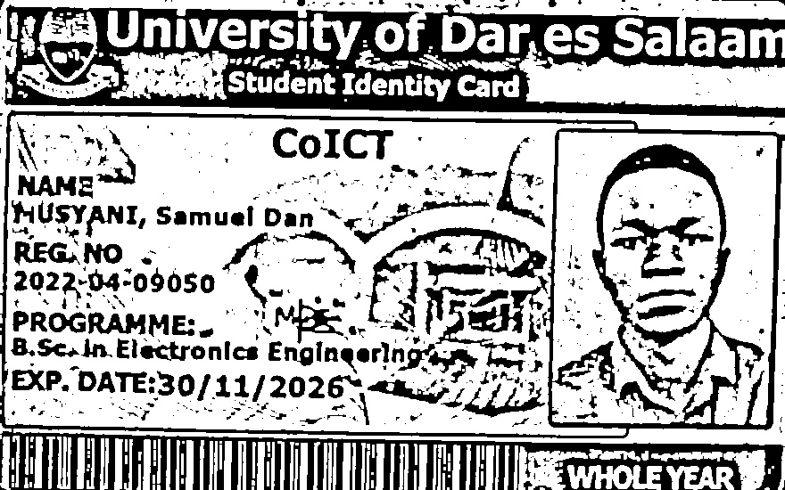
Figure 12: Adaptive thresholding on a sample card.
- Pixel – based ROI localization, a known localized region of a standard CR-80 card was measured and calculated to attain the exact area where the registration number is located. So, with a corrected image and thresholded sample, clear characters can be extracted from a concentrated region.
So, for a pre-ocr settings for the CR-80 card was measured through trial-and-error method and the optimal settings were acquired as shown below:
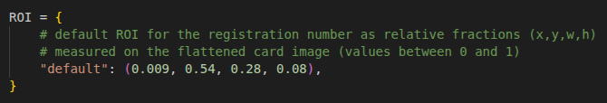
Figure 13: ROI settings for OCR
From the settings , there were outputs of regions of interest were observed for orignal, grayscale and threshold picture as to be shown below:
Figure 14: Previews of ROI outputs
- OCR extraction, validation and performance analysis, Tesseract OCR was used with prioritization of numeric recognition and validation of the extracted text against the institutional format. In addition to that, processing time and success message was extracted and logged into the system. The configuration settings for this are, English language, with single uniform text block (PSM 7), whitelist of alphanumeric characters only excluding the special symbols (Hyphen) in registration numbers.
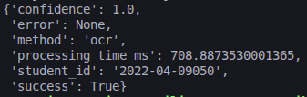
Figure 15: Text extraction and processing performances

4.1.2 USER INTERFACE
From the success part of the computer vision module, here comes the user interface responsible for interaction between the machine and the student in need of the card, communication with the database for authentication and validation of information and access validity together with hardware integration for physical activities such that card sorting and ejection. The UI is designed for a 5” touchscreen (TFT – Display) which will be connected directly to the raspberry Pi as a high level controller. So, the following are the screens and various transitions and conditions required:
- Idle welcome screen, this is the one that is displayed on the screen as long as the system is ON. This shows that the system is ready for student’s interaction.
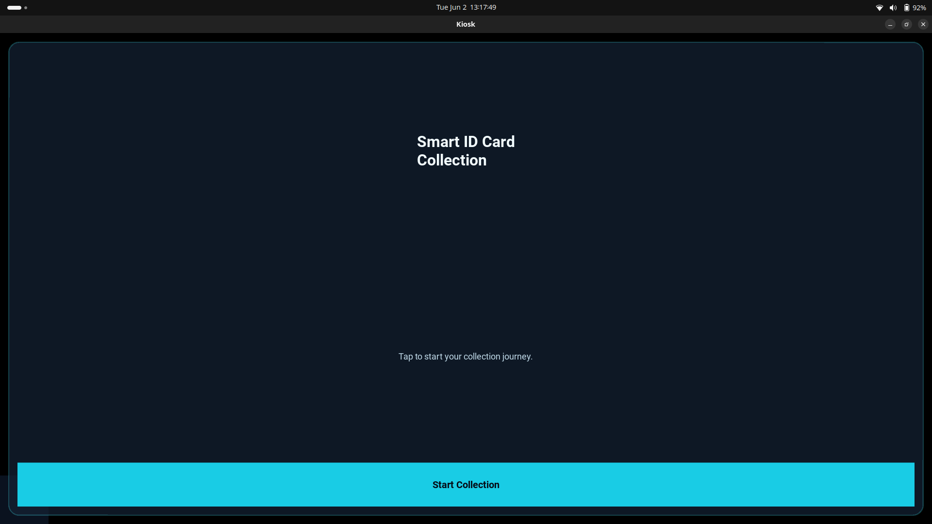
Figure 16: Idle UI screen for card kiosk
If a student presses the start collection button, it will transit to the next screen (registration entry screen) which prompts the student for his/her registration number.
- Registration number entry screen prompts the student to enter his/her registration number to which it is wired to the kiosk database. If should authenticate the student availability in the database. It checks for conditions such as if a student is not found, a card is already collected,
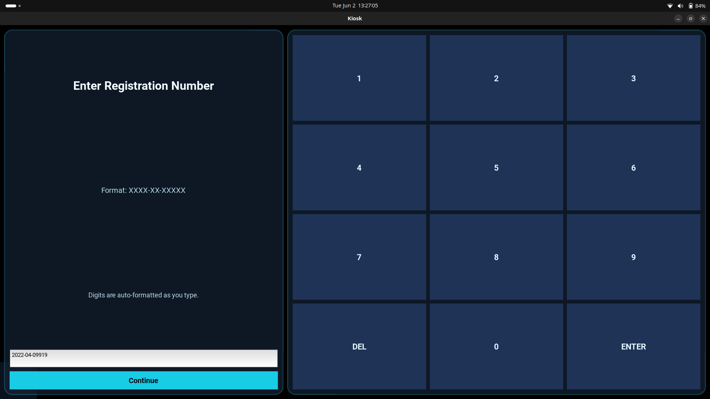
Figure 17: Initial registration number screen
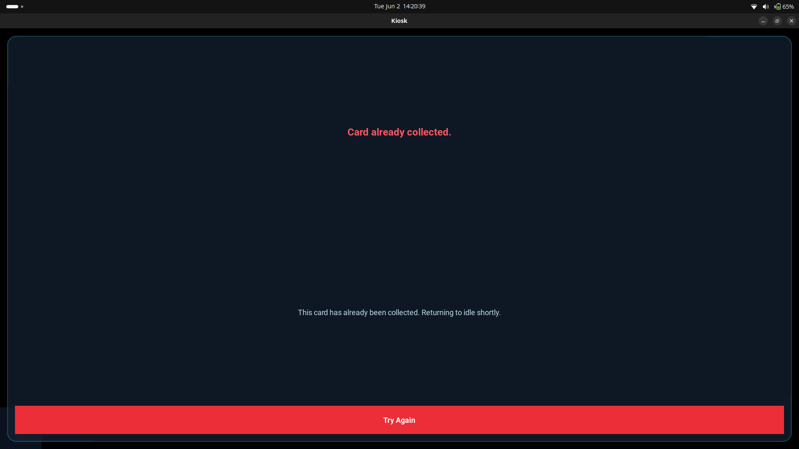
Figure 18: Registration entry screen for a repeated card
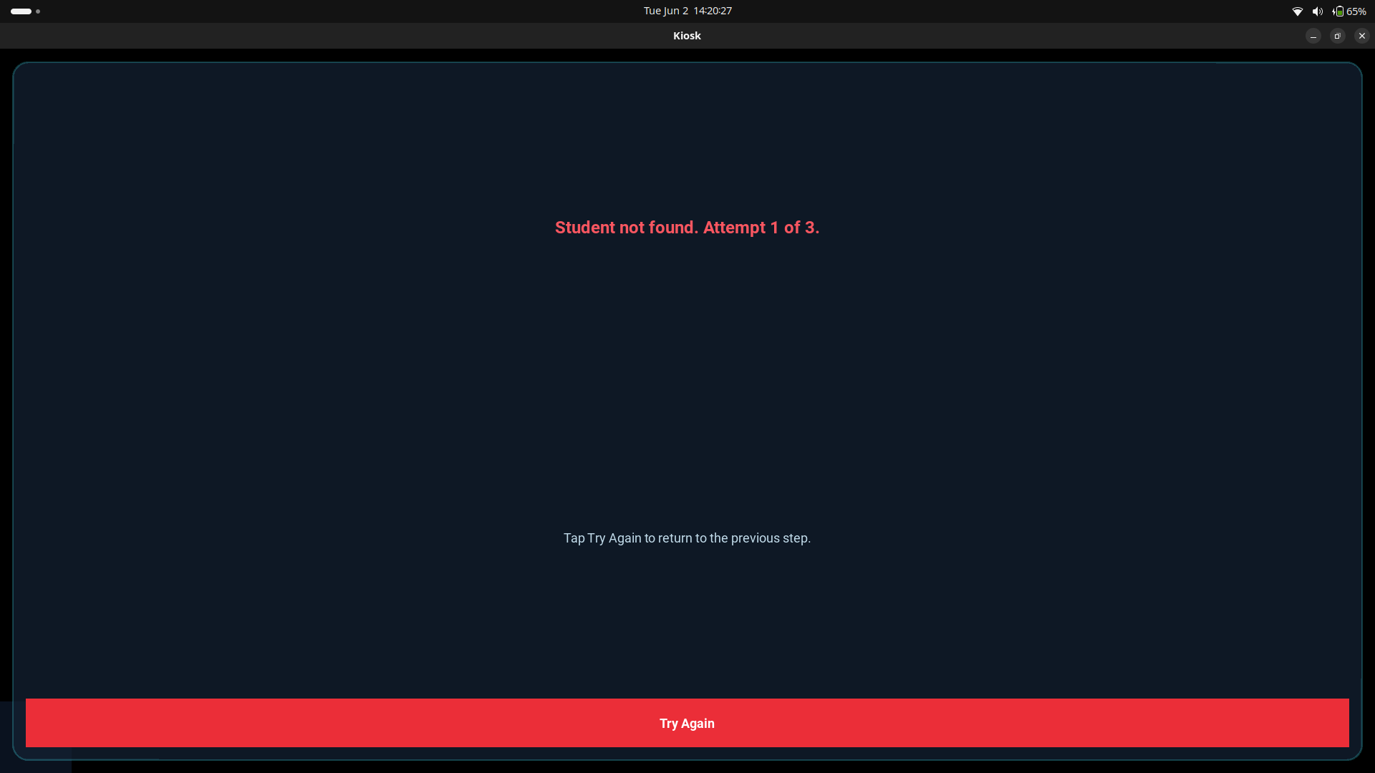
Figure 19: Registration entry screen for unavailable card
- OTP entry screen, student is required to enter a one time password as sent to the his/her email and phone number together. This screen validates the OTP and if correct, then the system transits to temporary PIN entry screen. If not, it warns the student and gives a maximum of three tries before the a lockout of the specific registration number.

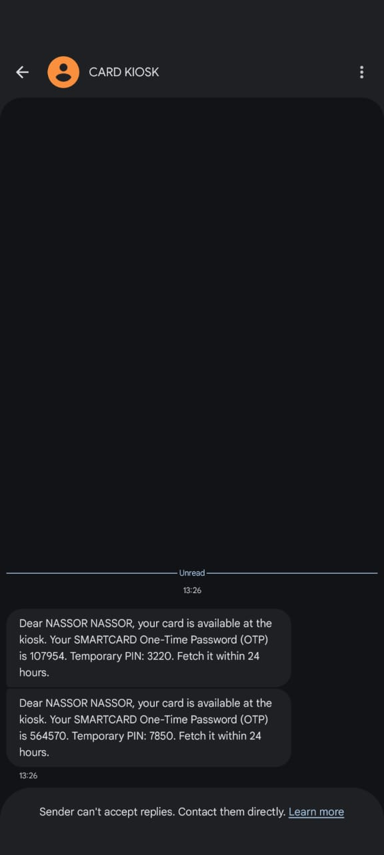
Figure 20: SMS message sent to sample student
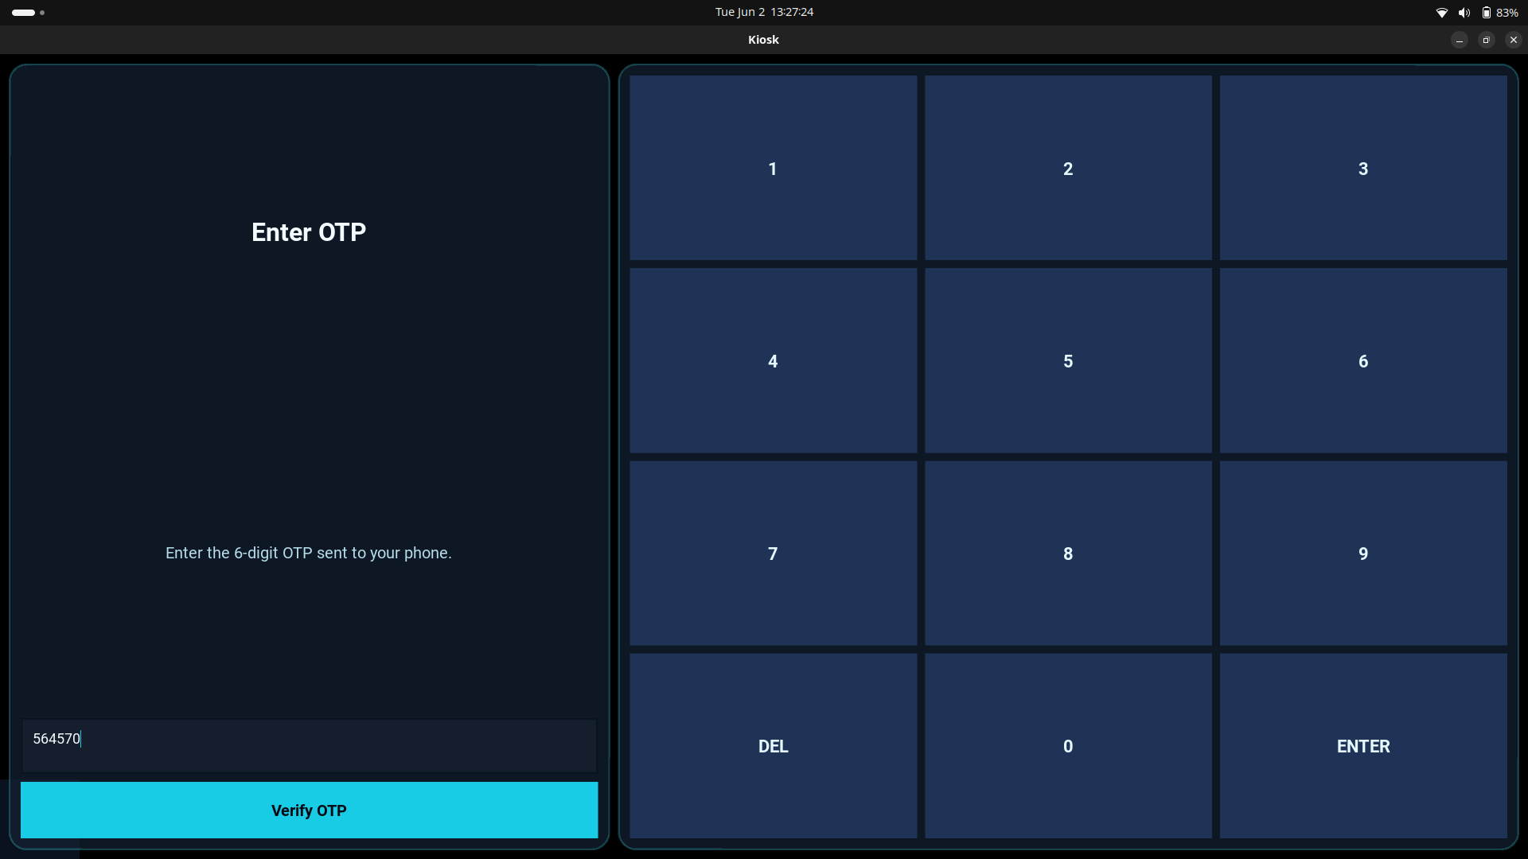
Figure 21: OTP initial screen
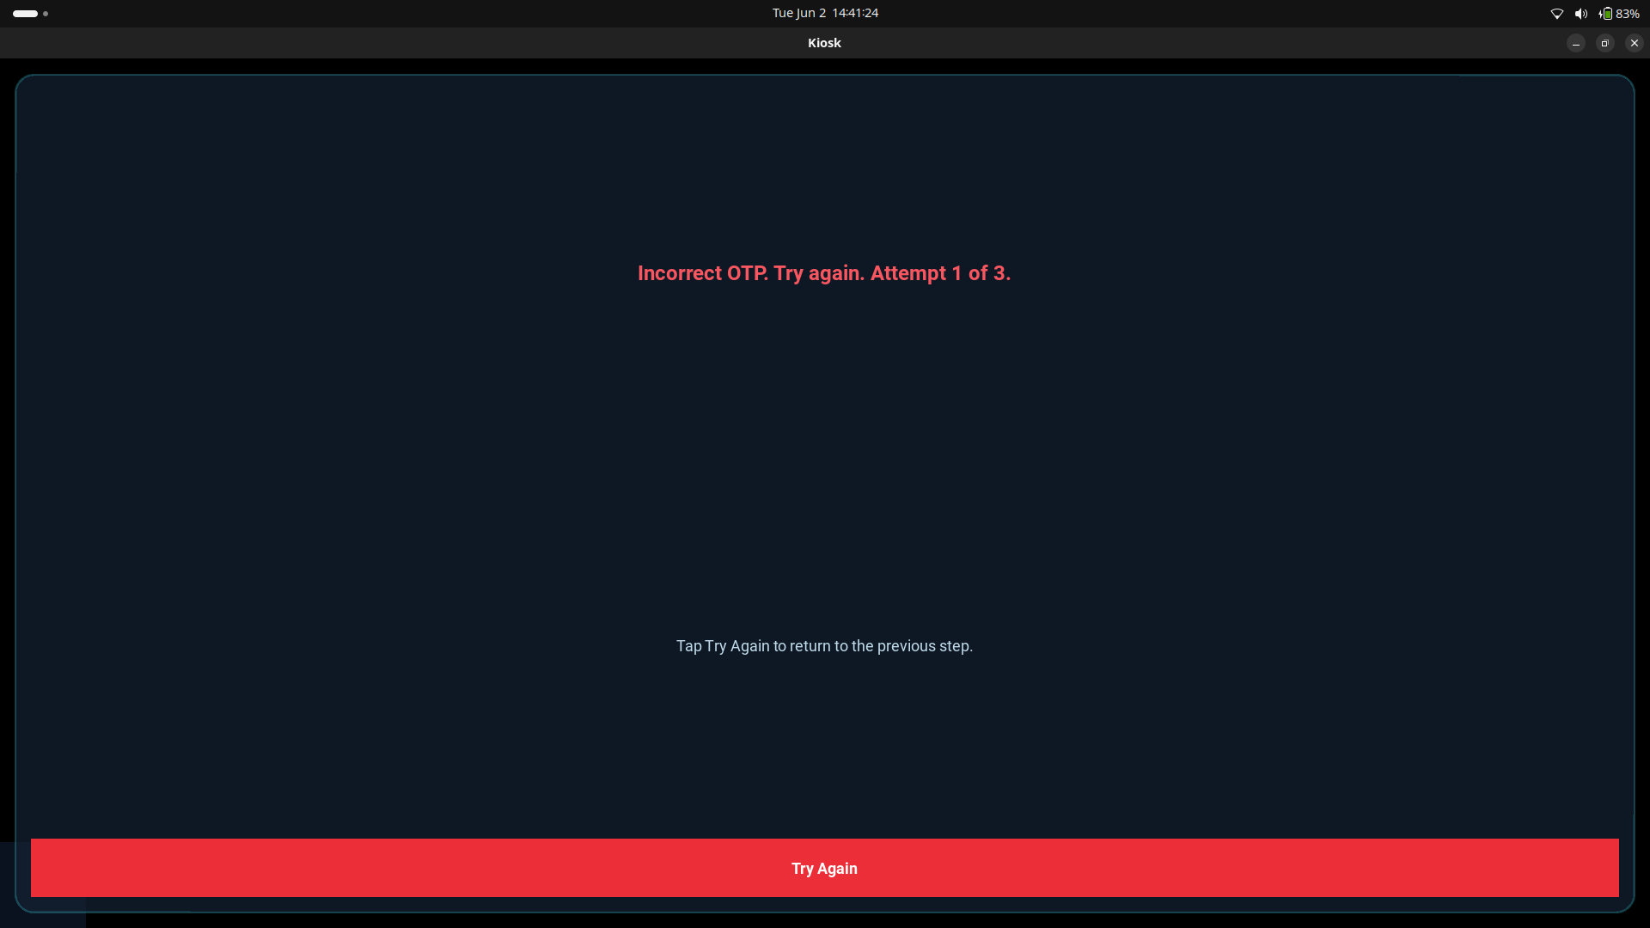
Figure 22: Incorrect OTP screen

- Temporary PIN screen, for first time users, the system prompts a student to enter a temporary PIN before setting their new PIN. The system uses two-factor authentication to enhance security during collection of delicate and crucial information of the student.
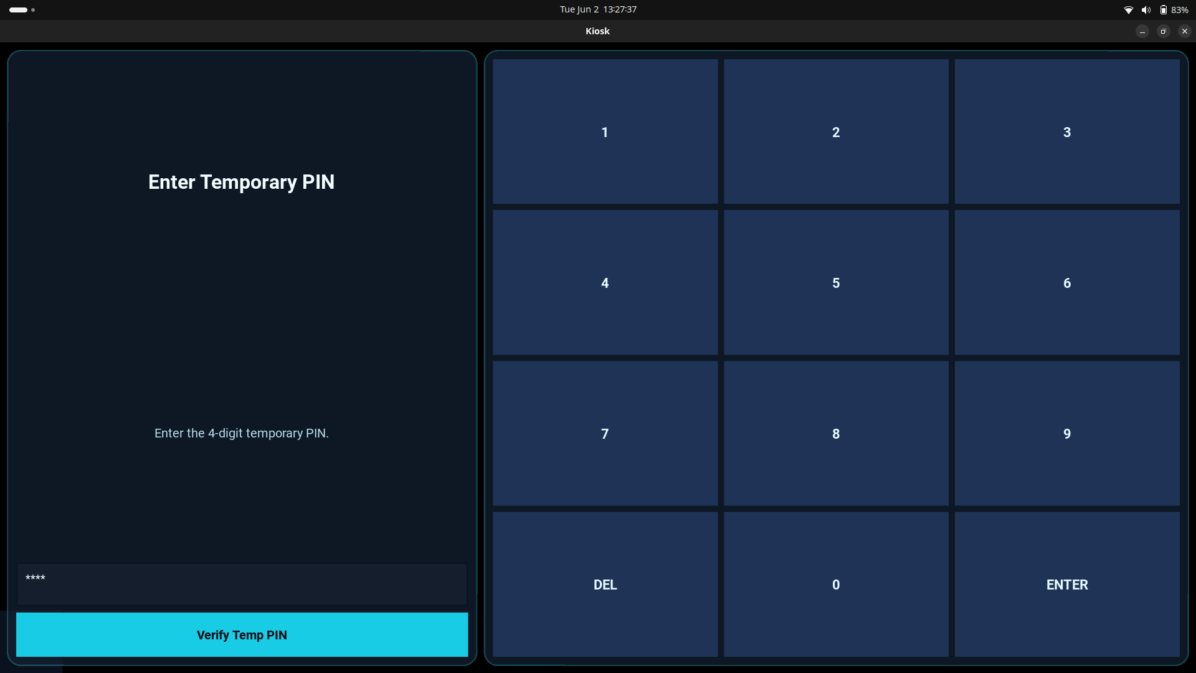
Figure 23:Temporary PIN screen – intial
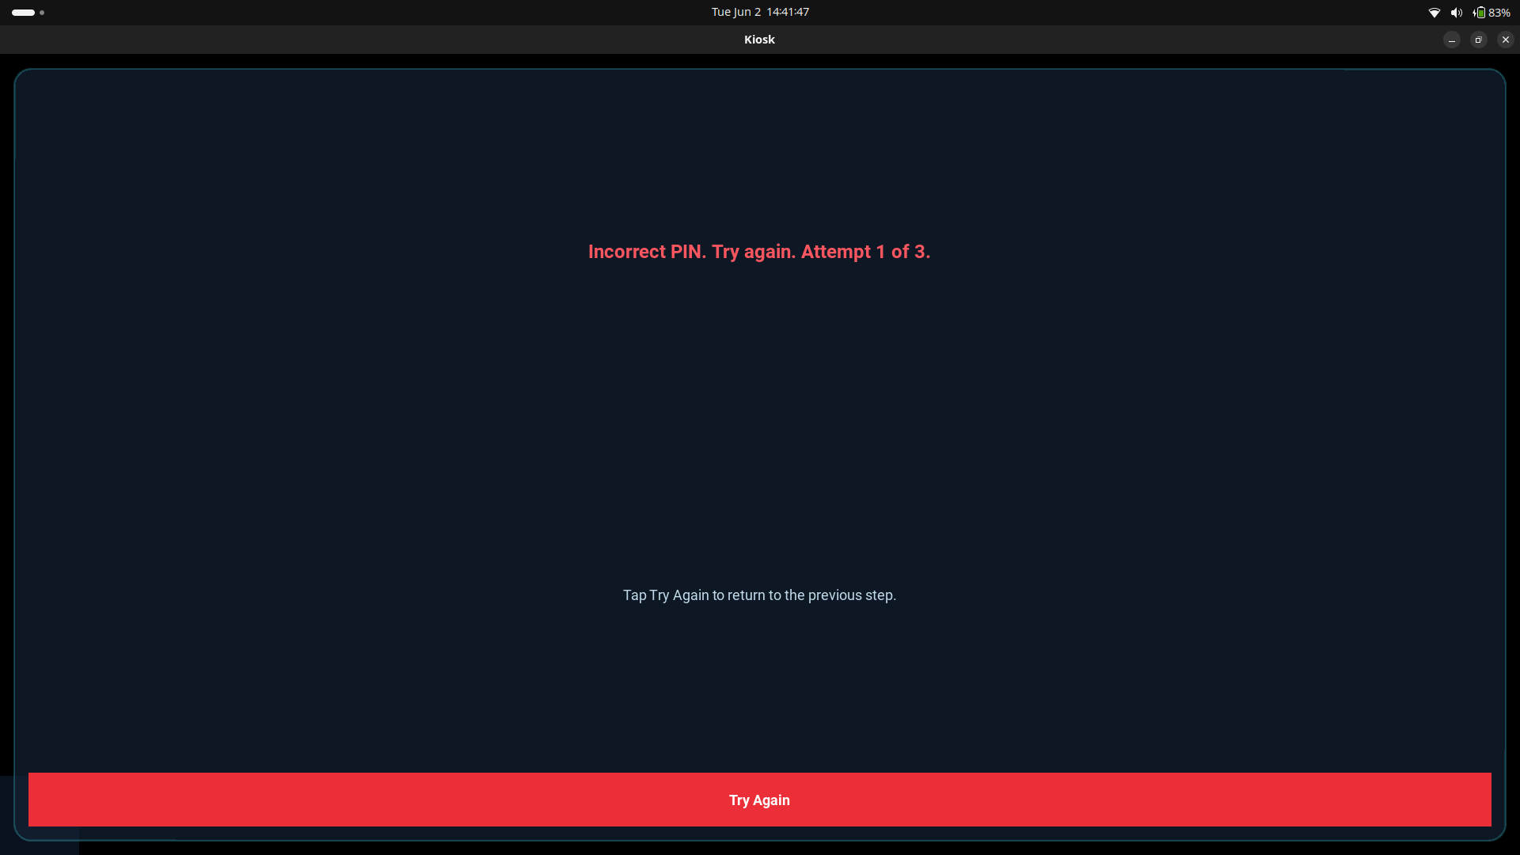
Figure 24: Incorrect PIN entered

- Card dispensing screen, this is a placeholder for hardware background activites. After setting the new pin, raspberry pi gives command to STM32 controller via SPI protocol to start card ejection process.
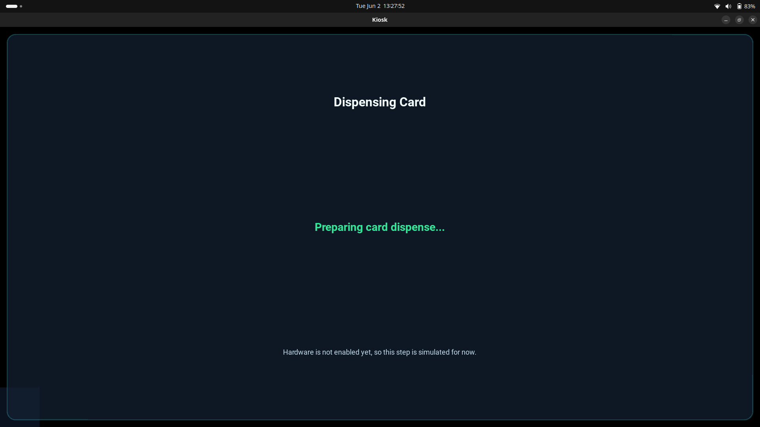
Figure 25: Hardware card dispensing - background
- Confirmation screen, this is the final screen that shows the student has already collected the card. This screen ends the session, and also audit all the logs into the database.
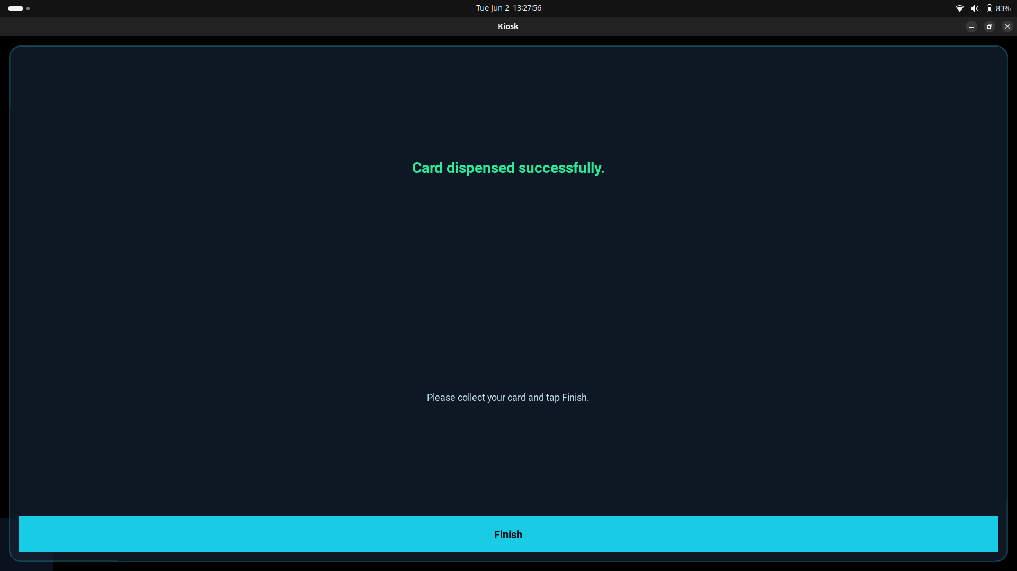
Figure 26: Final confirmation screen

4.1.3 OTP GENERATION AND VERIFICATION
On the implementation of OTP generation, python secrets module was used for cryptographic randomness, producing six digit numeric codes. The storage of these OTP codes are done by bcrypt hashing with salt rounds set to 12, preventing rainbow table attacks. The codes have 24 hour validity window from the generation timestamp, which can be changed on the main configuration file as the system admin wishes.
Figure 27: OTP generation
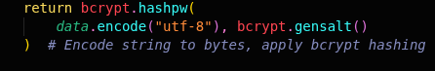
Figure 28: Bcrypt hashing with salt rounds
Delivery of the OTP is distributed into email, and SMS. For SMS, BRIQ Solutions’ API was used to send out messages to the required student (as the information is present in the database) while email app was used to send messages to default students’ emails provided by the University.

4.1.4 UNIVERSITY API INTEGRATION AND SLOT ASSIGNMENT
The OCR extracted registration numbers are validated against the University database. The University database used was the mock database with almost the same like architecture for the real one with simplicity and not strict security just for the prototype. The endpoint called by the raspberry Pi is HTTPS GET /students/{reg_number}. Authentication used is the bearer key which is also found in the configuration files. Timeout for the API call is 5 seconds with exponential back off retries with a maximum of 3 attempts.
The said API call handles file names such as first_name, surname, phone_number, email and other like personal information.
Upon successful validation, the system assigns an active slot on the round storage platform. The Round-robin allocation among three active slots (0-2) which are scalable. The application looks for a free slot in the database (slot_index) and puts the scanned card into the slot. The card scanned is linked to scan timestamp data and batch ID which are also stored in the database.

4.2 DATABASE ARCHITECTURE – KIOSK LOCAL
The SQLite database has data with five normalized tables designed for audit compliance and query efficiency.
TABLES | COLUMNS | PURPOSE
Students | id (PK), registration_number (UNIQUE), first_name, last_name, email, phone, programme, status | Student master records; single source of truth for student information
Authentication | d (PK), student_id (FK), otp_hash, otp_generated_at, otp_verified_at, temp_pin_hash, permanent_pin_hash, is_temp_pin, failed_otp_count, failed_pin_count, otp_lockout_until, pin_lockout_until, last_activity | Credential storage with bcrypt hashes; lockout state management
Cards | id (PK), card_number (UNIQUE), student_id (FK), slot_index, batch_id (FK), status (pending_collection or collected or rejected), created_at, collected_at | Physical card tracking; links students to assigned dispenser slots
Audit Log | id (PK), registration_number, session_id, event_type (registration or otp_generated or otp_verified or pin_verified or card_collected or error), failure_reason, timestamp | Immutable append-only log for regulatory audit trail
Batches | id (PK), batch_name, staff_id, card_count, scanned_at | Metadata for batch ingestion events
Table 4: Schema Overview
For this presented schema overview, the indexing strategy in those columns goes as follows; in students table, registration numbers for fast student lookup during collection, in audit log, chronological log traversal and for cards, student_id and status for query pending cards for given students.

4.3 API CLIENT MODULE AND SMS DELIVERY
From the application, a module dedicated for api client activites abstracts communication with the mock university database. The key features are as follows:
- mDNS discovery: automatically resolves university-db.local (my computer for this prototype) on startup with a requirement of Avahi daemon package
- Bearer key, a security configurable API key in the configuration file
- Timeout handling, 5 second timeout with exponential backoff with maximum of 3 attempts.
- Fallback caching, this returns the cached student records if the network is unavailable.
After the OTP generation, the system was configured to use BRIQ Solutions, a Tanzania – based SMS gateway with the following configuration requirements:
- BRIQ API KEY: authentication token from one’s own BRIQ account.
- BRIQ SENDER ID: sender name to be displayed to the reciever. For this project, the sender ID is CARD KIOSK
- BRIQ BASE URL: endpoint that communicates the application and the BRIQ’s dedicated account.
From all these configuration, sending message from the application to student’s personal number retrieved from the Universtiy database is made possible. The following are the steps towards sending the SMS:
- Construction of a message with OTP generated with a temporary PIN for first users.
- POST request to BRIQ “/v1/message/send-instant” with a referenced API key.
- Log the delivery status to the audit log table
- On failure, queue for retry every 15 minutes (up to 3 attempts)
Credential delivery is only considered successful when at least one channel (SMS or email) proceeds. This means that the receiver has got the OTP successfully.

4.4 SESSION MANAGEMENT
The session manager class maintains per transaction states in volatile memory (RAM). Initialization of a session is done on the registration number entry on the UI, with state varibales such as validated flags on OTP and PIN, assigned slot index, and student ID. Teardown is done on the end of transaction or inactivity for a timeout of 60 seconds. The session ID is logged into the audit log for transaction correlation.

4.5 CONFIGURATION MANAGEMENT
In the raspberry Pi application, a dedicated module that centralized all configurable parameters is implemented but isolated from the version control due to presence of critical secrets such as API KEYS, and passwords. The parameters contained in there are:
- Database: DB_PATH, connection for the database
- APIs: UNIVERSITY_API_BASE_URL, UNIVERSITY_API_KEY, timeouts, retry policies
- SMS: BRIQ_API_KEY, BRIQ_SENDER_ID, BRIQ_BASE_URL
- Email: SMTP_EMAIL, SMTP_PASSWORD (app-specific, not account password)
- Camera: Device candidates, capture resolution (1920×1440), frame rate, thresholds
- OCR: Perspective correction size, registration ROI coordinates, preprocessing values
- UI: Timeout intervals, attempt limits, lockout durations

CHAPTER FIVE: HARDWARE IMPLEMENTATION AND PROGRESS

5.1 MICROCONTROLLER SELECTION AND CONFIGURATION
The current project hardware implementation targets Arduino Mega 2560, a 16MHz AVR based micro controller, with the following hardware specifications:
- Clock speed: 16 MHz crystal oscillator
- Memory: 256 KB Flash, 8 KB SRAM, 4 KB EEPROM
- GPIO Pins: 54 digital I/O, 16 analog inputs
- Hardware Peripherals: SPI (slave mode), UART (serial monitor), PWM timers
- Programming: PlatformIO framework with AVR HAL abstractions in Visual Studio Code IDE
The original microcontroller choice was STM32 Nucleo-F401RE with 1MHz SPI, but this substitution due to logistics maintains compatibility through platformIO abstraction with an improvise of speed for SPI at 100 kHz.

5.2 SPI SLAVE CONFIGURATION
The micro-controller operates as a slave (SPI), receiving two-byte ASCII frame commands from the raspberry Pi master. The pin mapping of the connection configuration is as follows:
- SS (Slave Select): pin 53 (active low), with pin 24 from Raspberry Pi
- MOSI (Master Out Slave In): pin 51, with pin 19 from Raspberry Pi
- SCK (Serial Clock): pin 52, with pin 23 from Raspberry Pi
With considerations of different operating voltages between Raspberry Pi and the arduino Mega, since the slave does not send any signal to its master, hence no level shifting is required.

5.3 SPI COMMUNICATION PROTOCOL
The current implementation uses a two-byte ASCII frame format:
- Byte 0: command character (0 – 9, A – Z)
- Byte 1: parameter character (0 – 9, slot index)
Example status frames are:
- “00”: processing error
- “1X”: 1 – success, X – slot index
- “2X”: 2 – retrieve, X – slot index
The current firmware implements basic frame reception and servo test routines.

5.4 SERVO MOTOR CONTROL
The firmware configures hardware PWM outputs for servo motor controls. The servo type in conversation is SG90 with 180 degrees physical constraints.
- Pin 22: card holder for scanning card during entrance
- Pin 23: carousel rotation motor controlled
For servo control, pulses vary from 544 µs to 2400 µs, to rotate from 0 to 180 degrees.

5.5 FIRMWARE ARCHITECTURE
The arduino Mega firmware follows a cooperative multitasking pattern with SPI hardware interrupts. The main loop structures goes as follows:
- Poll SPI SPIE flag for received framework
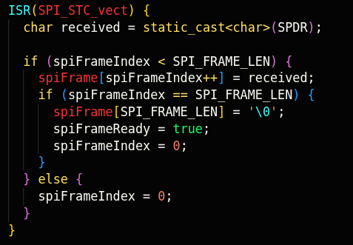
Figure 29: SPI poll initialization
- Extract two-byte command and parameter from SPI buffer
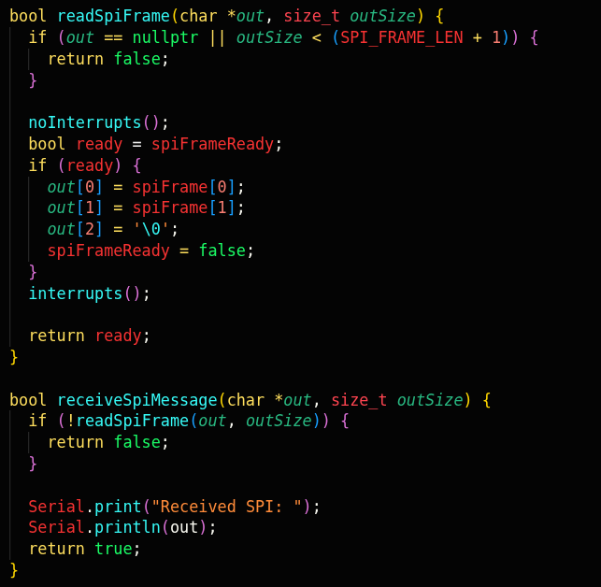
Figure 30: Frame extraction from buffer
- Dispatch command to state machine

Figure 31: Dispatch to state machine
- Drive servo motors according to the received SPI buffer.
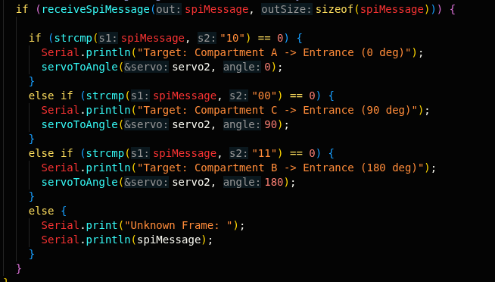
Figure 32: Choice statements

CHAPTER SIX: RECOMMENDATIONS AND CONCLUSION

6.1 RECOMMENDATIONS
Considering the status and the risk of Implementation, I suggest the first prototype be installed at the main university campus rather than separate college locations. This recommendation is driven by three technical and operational considerations. First, the system has achieved 95% software completeness but about 65% mechanical hardware integration, requiring proximity to development resources for troubleshooting the carousel homing sequences, SPI timing validation, and calibration of sensor feedback. Second, the main campus has the largest student population, providing a sufficiently large transaction volume for validation of authentication workflows, detection of OCR failure modes under realistic variations of the lighting and card conditions, and stress testing of the SQLite database under peak concurrency conditions. Third, the centralized deployment allows iterative refinement of the core system prior to deploying replicated instances across geographically dispersed college campuses.
But deployment on the main campus should not mean permanent centralization. After 90 days of operation without any critical hardware failures I would suggest rolling out a second kiosk to the largest isolated college campus. This secondary deployment is a validation point for the consistency of the multi-instance architecture: database replication needs, API caching strategies, network failure scenarios, and configuration management patterns are not derivable from a single kiosk in ideal circumstances. The geographically separate college location naturally isolates future enhancement testing, such as the printer workflow discussed below, from main campus operations and user experience.
In addition to reducing mechanical complexity during the crucial hardware integration window, the present prototype dispenses cards without access control barriers, which is suitable for validation. Similarly, once motor control, sensor feedback, and slot homing are demonstrated to be dependable in production, expanding storage capacity (e.g., from four active slots to ten or adding a second carousel tier) is a straightforward mechanical modification. On-demand card printing is the higher-value Phase 2 project. Once the SPI dispensing protocol is established and the current system consistently connects students with physical pre-printed cards, retrofitting a thermal or inkjet printer into the dispensing assembly eliminates the need for an OCR pipeline, completely eliminates staff batch-loading workflows, and drastically lowers administrative overhead.

6.2 CONCLUSION
The Smart ID Card Issuance Kiosk project demonstrates a practical application of embedded systems, real-time control, and distributed computing to address operational challenges in higher education. The implementation achieves functional completeness at the application and database layers, with a foundational SPI protocol and microcontroller framework ready for production hardware integration.
Current Status: The system is at Phase 4 (95% complete for software, 75% for mechanical hardware). All software modules are implemented and testable; OCR pipeline validation, authentication workflows, and database audit logging are production-ready. SPI communication is established and verified at the protocol level, with servo control and basic hardware interaction demonstrated via firmware.
Immediate Next Steps: Connect the remaining UI flows (returning-student PIN verification, hardware dispensing acknowledgement), complete the microcontroller state machines for carousel and conveyor control, and assemble mechanical hardware for end-to-end validation testing.
By completing the hardware integration phases and resolving the known issues outlined in Section 7, this project will deliver a fully functional, scalable, and auditable ID card distribution system suitable for deployment across university campuses in resource-constrained environments.

REFERENCES
- Ratnasri, Nilani & Sharmilan, Tharaga. (2021). Vending Machine Technologies: A Review Article. International Journal of Sciences: Basic and Applied Research (IJSBAR). 58. 160-166.
- https://docs.briq.tz/karibu
- Aman Prasad, Shraddha Kumar, Keshav Shriram, Prof. Dr. Vikram Mane, “IOT Based Pen Vending Machine”, Published in International Research Journal of Innovations in Engineering and Technology-IRJIET, Volume 8, Issue 3, pp 367-373, March 2024. Article DOI https://doi.org/10.47001/IRJIET/2024.803057
- Bai, Y., Hu, J., Liu, J., & Zhou, Q. (2012). Card transport device and ATM using same (U.S. Patent No. US8251282B2). U.S. Patent and Trademark Office.
- Instructables User “Joe_Squared”. (2017). DIY trading card dispenser project. Instructables.
- Peter Kibaya, Charles S Lubobya (2024) Design of a Multifactor Authentication System for Automated Teller Machines. 1: 1-17
- Halac et al. Journal of Engineering and Applied Science, (2025) 72:187. https://doi.org/10.1186/s44147-025-00763-0
- Xia, K., Fan, H., Huang, J., Wang, H., Ren, J., Jian, Q., & Wei, D. An Intelligent Self-Service Vending System for Smart Retail. Sensors, 21(10), 3560. https://doi.org/10.3390/s21103560

